Assigment no 13:

.
1) Create a union of two queries that shows the
names, cities, and ratings of all customers. Those
with rating of 200 or greater will also have the
words “High Rating”, while the others will have
the words “Low Rating”.

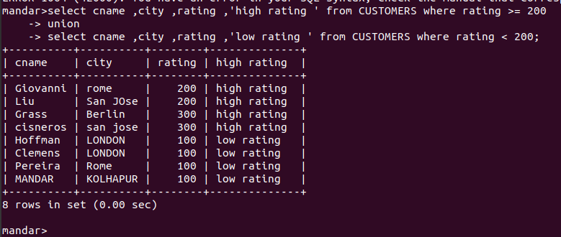

2) Write a command that produces the name and
number of each salesperson and each customer with
more than one current order. Put the results in
alphabetical order.
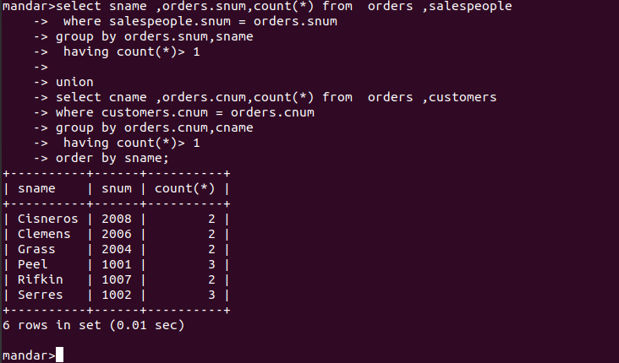

3) Form a union of three queries. Have the first
select the snums of all salespeople in San Jose;
the second, the cnums of all customers in San
Jose; and the third the onums of all orders on
October 3. Retain duplicates between the last two
queries but eliminate any redundancies between
either of them and the first.
(Note: in the sample tables as given, there would
be no such redundancy. This is besides the point.)

